Feeler Gauge
# Source: AI Source: Provided by: [Data Path: Persons Table -> ID Column: 1, Name_En Column: Motasem Essam] -> From: [ChatGPT] on [7/17/2026]
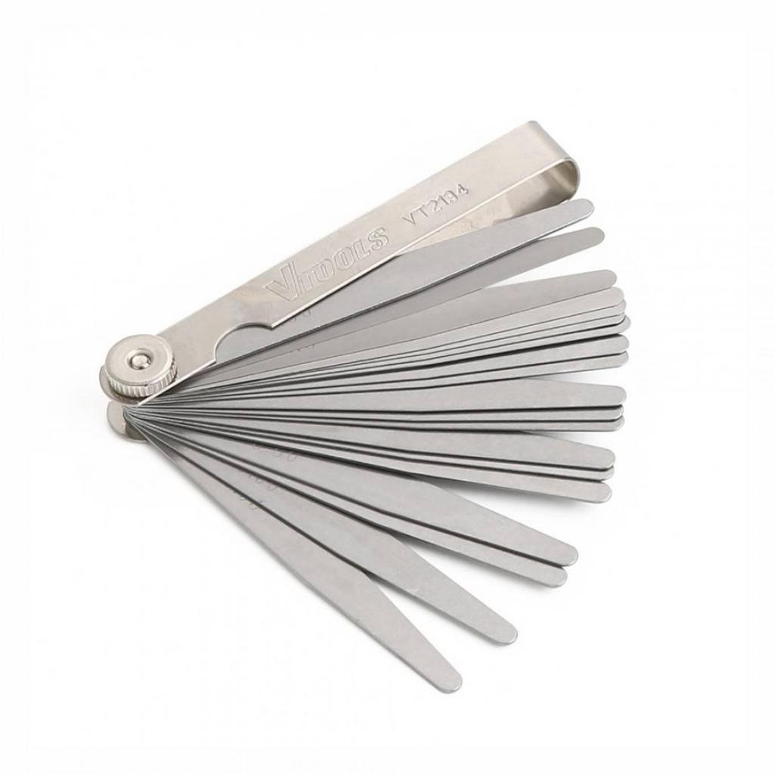
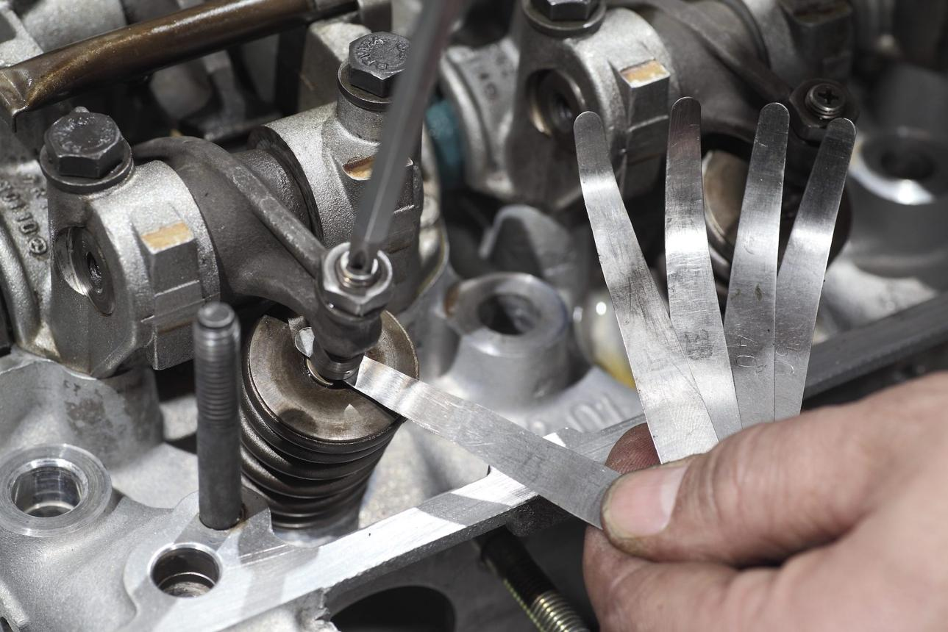
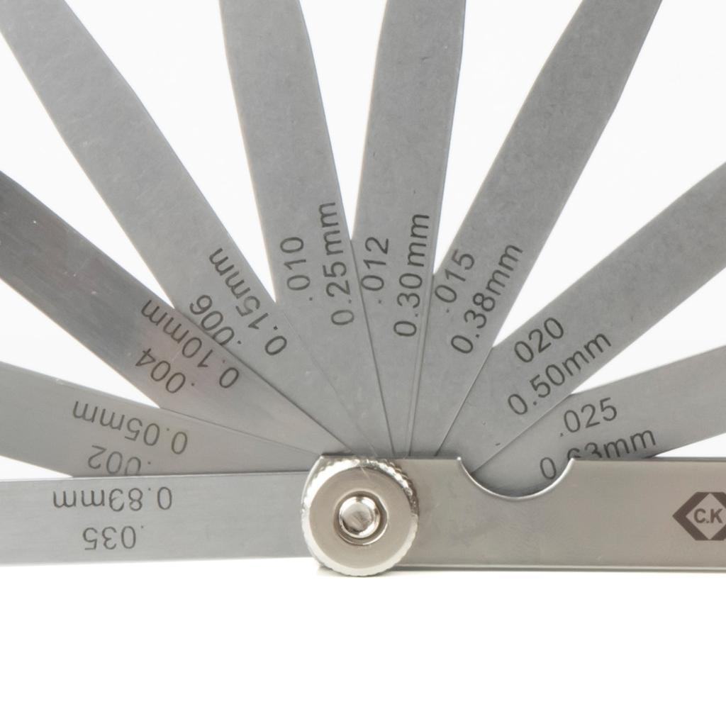
A Feeler Gauge is a precision measuring instrument consisting of a set of thin metal blades (leaves) of accurately known thickness. It is used to measure the width of small gaps or clearances between two closely spaced surfaces.
Feeler gauges are widely used in mechanical engineering, automotive maintenance, machining, manufacturing, quality control, and equipment servicing.

Definition
# Source: AI Source: Provided by: [Data Path: Persons Table -> ID Column: 1, Name_En Column: Motasem Essam] -> From: [ChatGPT] on [7/17/2026]
A Feeler Gauge is a precision measuring tool made of thin blades of known thickness, used to measure or set small gaps, clearances, and spacing between two surfaces.

Purpose
# Source: AI Source: Provided by: [Data Path: Persons Table -> ID Column: 1, Name_En Column: Motasem Essam] -> From: [ChatGPT] on [7/17/2026]
A Feeler Gauge is used to:
- Measure narrow gaps.
- Measure clearances.
- Set mechanical clearances.
- Check alignment.
- Inspect tolerances.
- Adjust machine components.
- Verify spacing between parts.

Principle of Operation
# Source: AI Source: Provided by: [Data Path: Persons Table -> ID Column: 1, Name_En Column: Motasem Essam] -> From: [ChatGPT] on [7/17/2026]
A feeler gauge works by inserting one or more blades into the gap.
- If the blade fits with slight resistance, its thickness equals the gap.
- If one blade is too thin or too thick, another blade—or a combination of blades—is selected until the correct fit is achieved.

Main Components
# Source: AI Source: Provided by: [Data Path: Persons Table -> ID Column: 1, Name_En Column: Motasem Essam] -> From: [ChatGPT] on [7/17/2026]
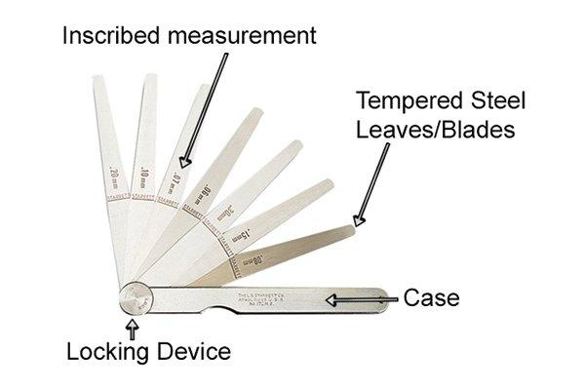
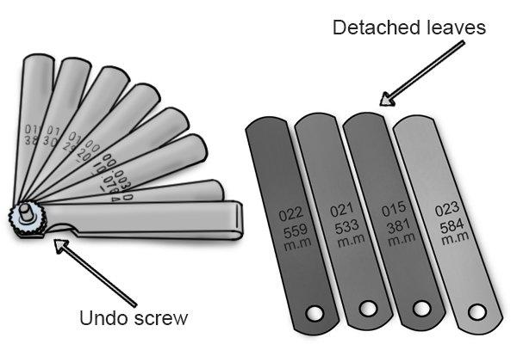
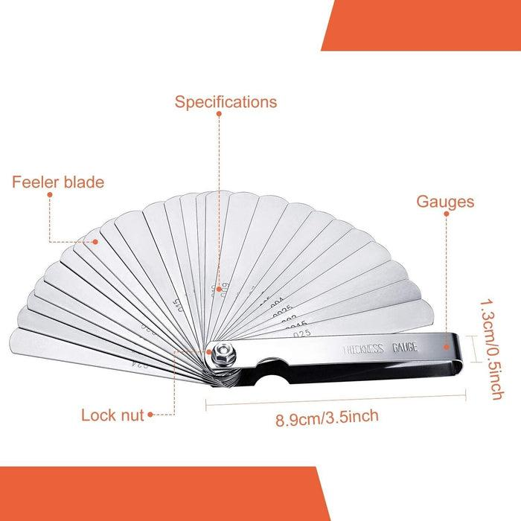
A typical feeler gauge consists of:
- Steel blades (leaves)
- Thickness markings
- Pivot screw
- Protective holder/frame

Types of Feeler Gauges

1. Standard (Straight) Feeler Gauge
# Source: AI Source: Provided by: [Data Path: Persons Table -> ID Column: 1, Name_En Column: Motasem Essam] -> From: [ChatGPT] on [7/17/2026]
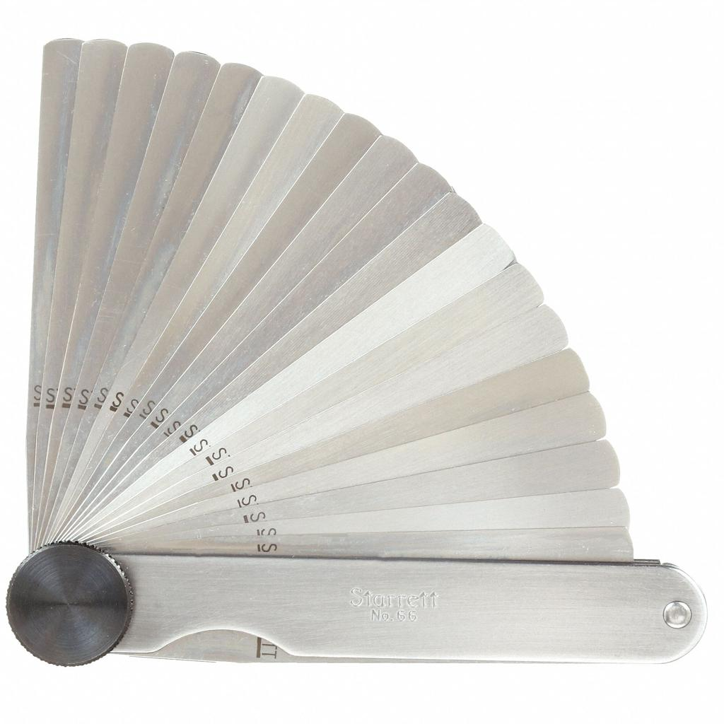
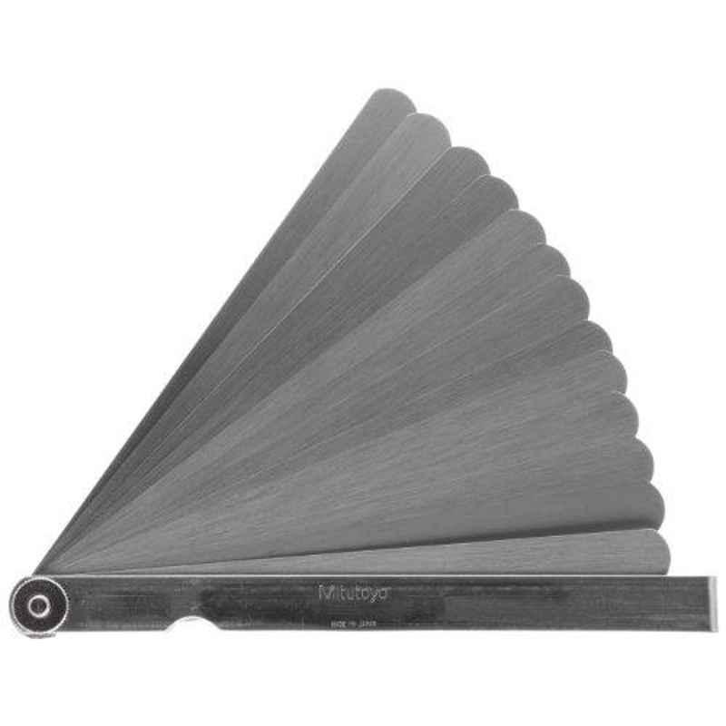
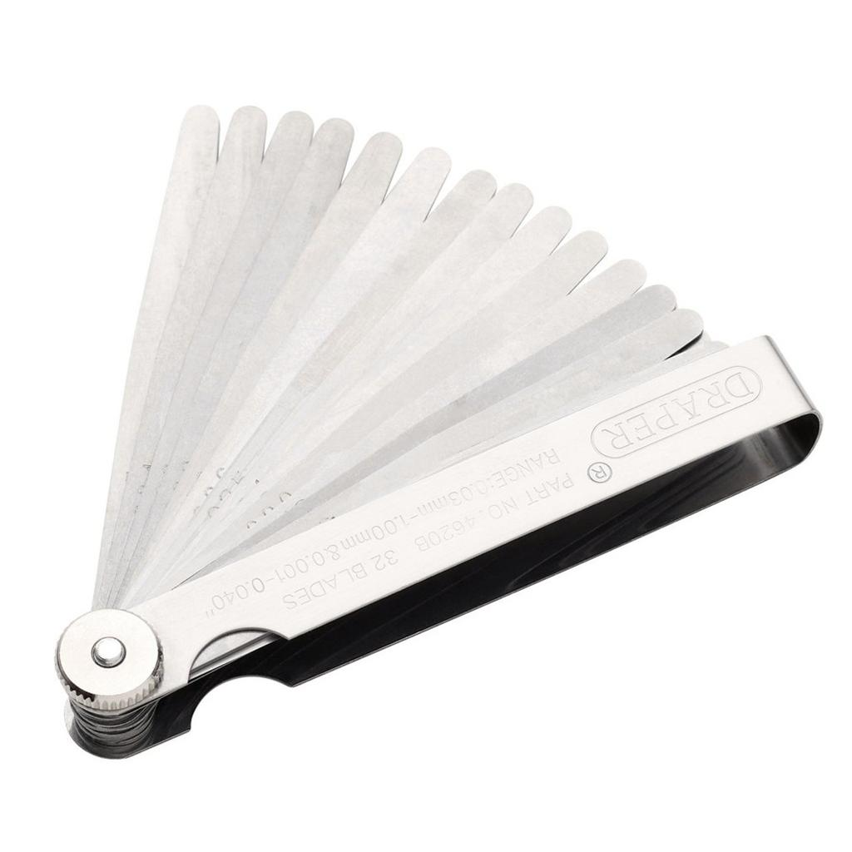
Description
The most common type, with straight blades that pivot from a central holder.
Applications
- General mechanical measurements
- Machine setup
- Workshop inspection

2. Offset Feeler Gauge
# Source: AI Source: Provided by: [Data Path: Persons Table -> ID Column: 1, Name_En Column: Motasem Essam] -> From: [ChatGPT] on [7/17/2026]
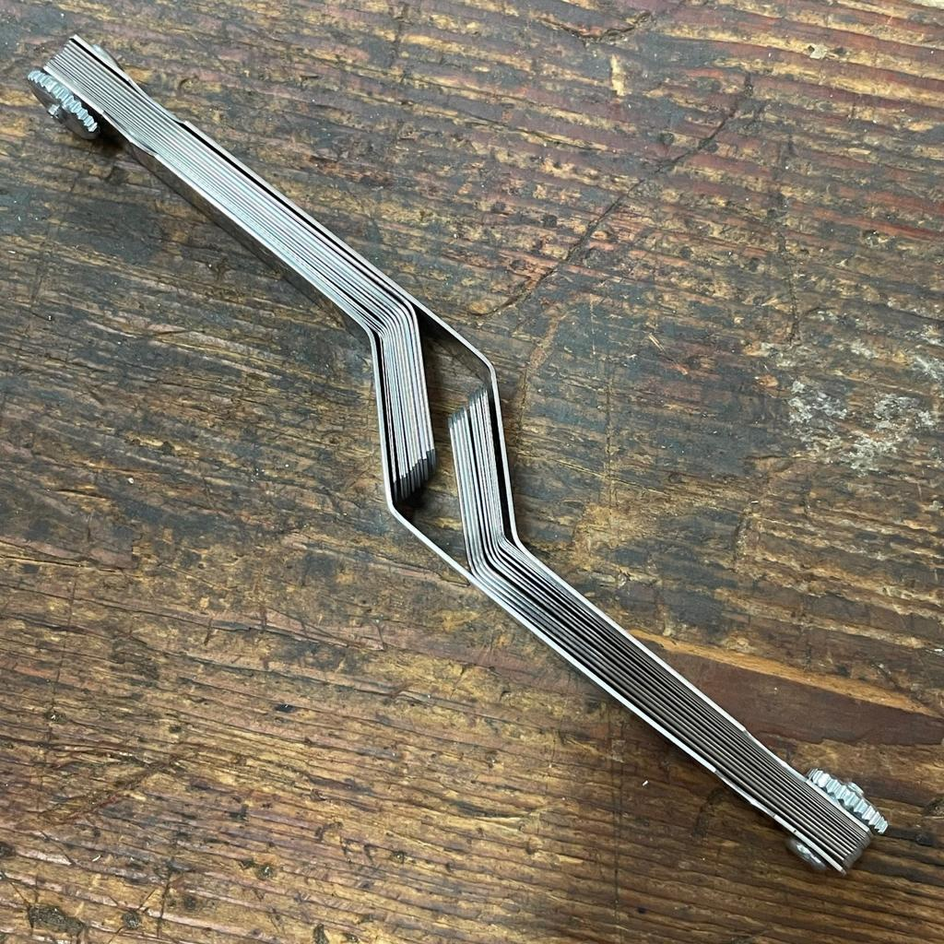
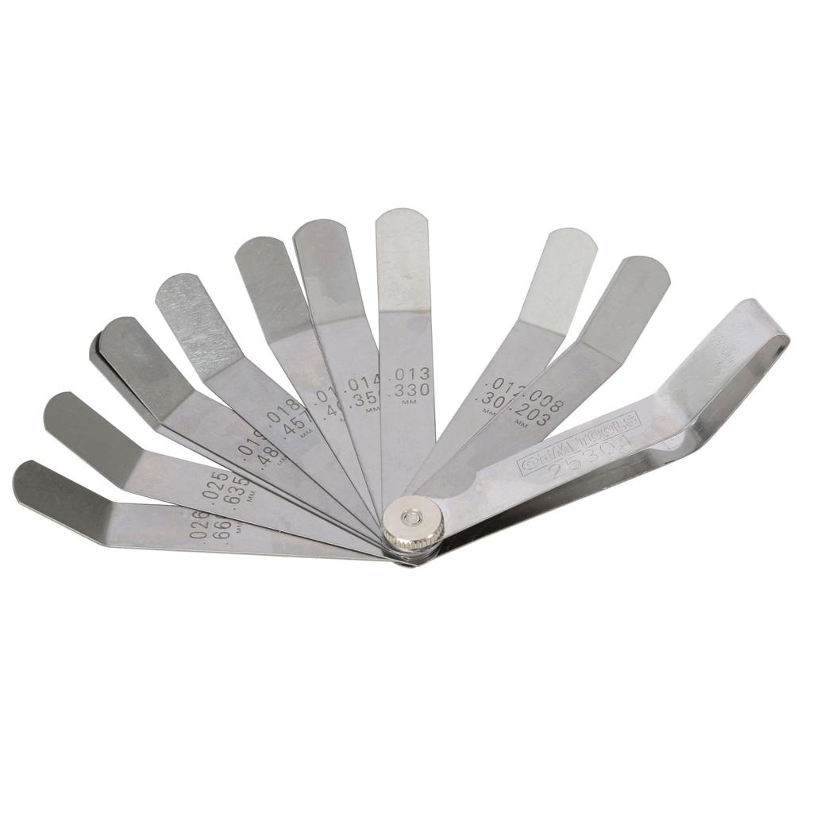
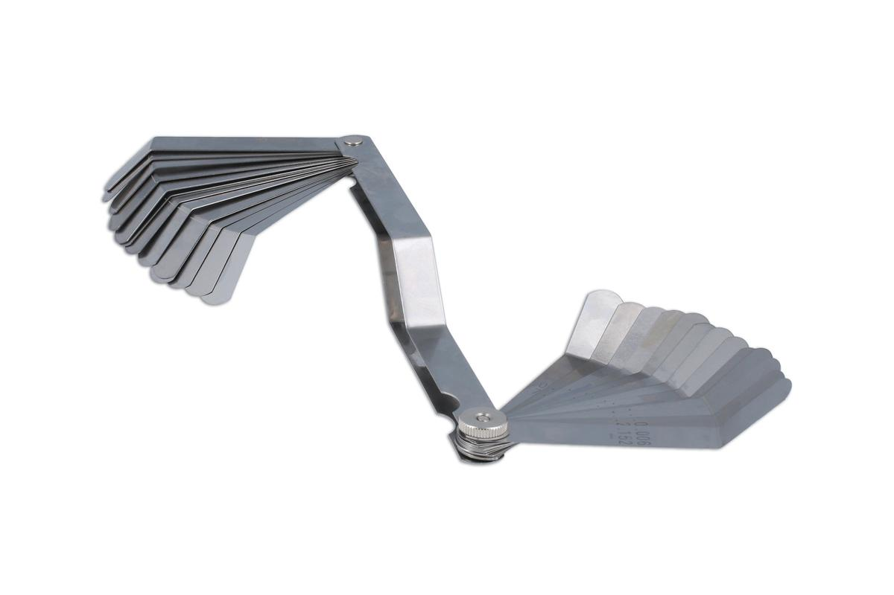
Description
The blades are bent near one end to allow access to difficult or recessed measuring locations.
Applications
- Engine maintenance
- Restricted-access machinery
- Tight assemblies

3. Tapered Feeler Gauge
# Source: AI Source: Provided by: [Data Path: Persons Table -> ID Column: 1, Name_En Column: Motasem Essam] -> From: [ChatGPT] on [7/17/2026]

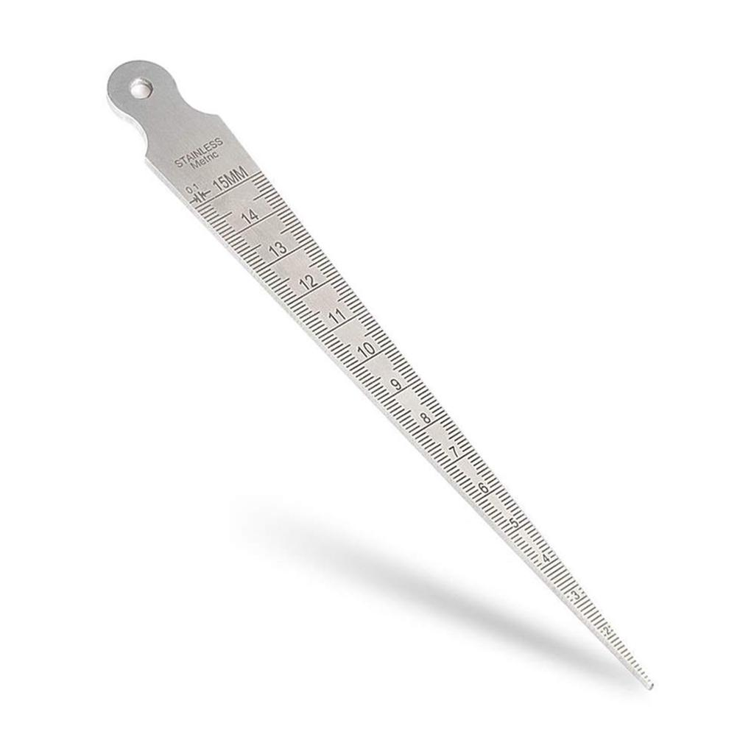
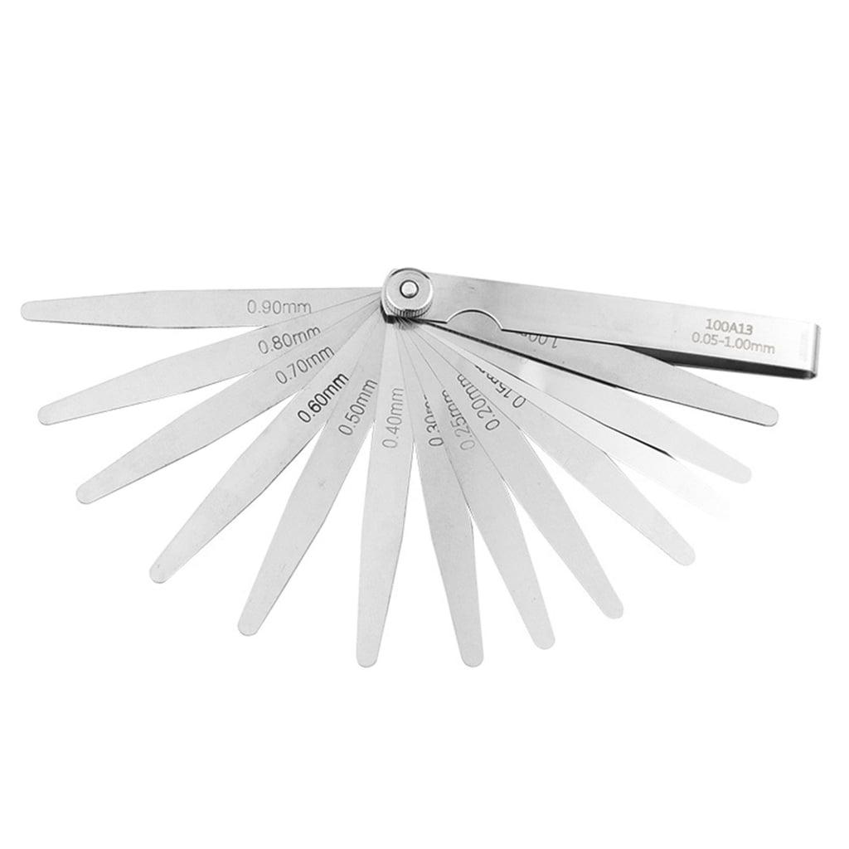
Description
Each blade gradually increases in thickness, allowing continuous measurement over a range.
Applications
- Measuring irregular gaps
- Precision fitting
- Specialized inspection

4. Brass / Non-Magnetic Feeler Gauge
# Source: AI Source: Provided by: [Data Path: Persons Table -> ID Column: 1, Name_En Column: Motasem Essam] -> From: [ChatGPT] on [7/17/2026]
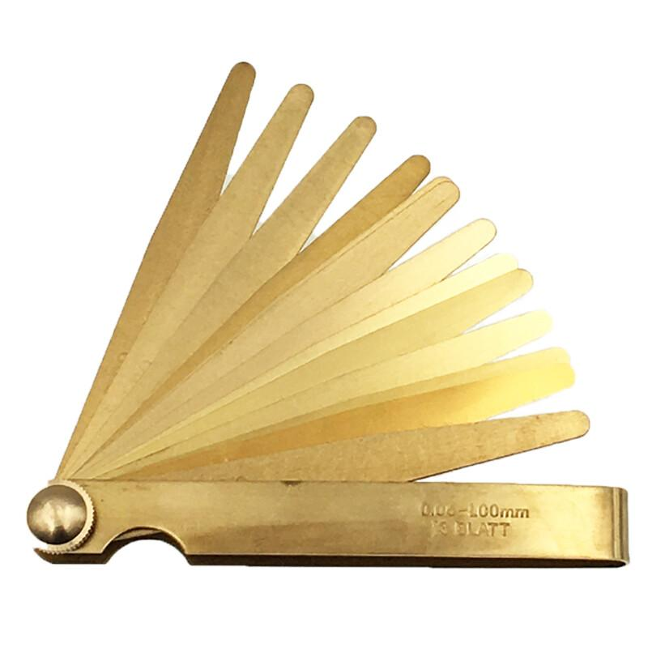
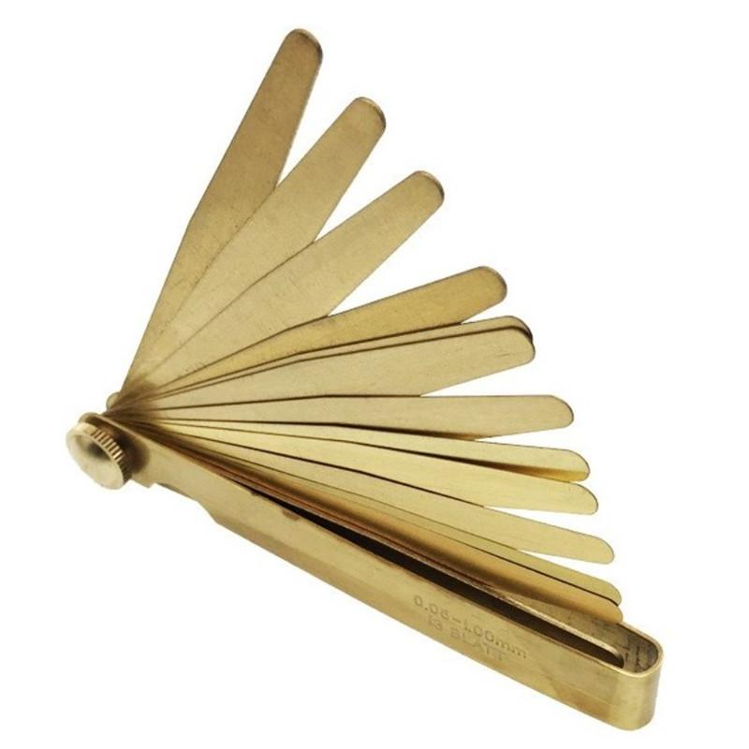
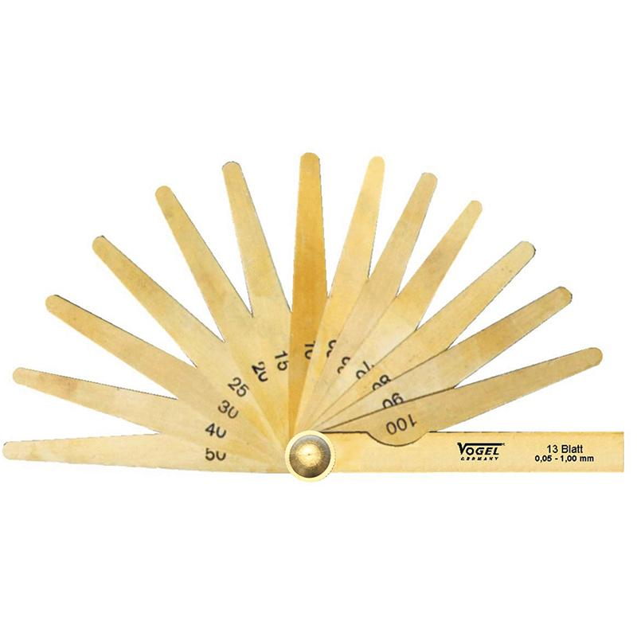
Description
Made from brass or other non-magnetic materials for use where steel blades are unsuitable.
Applications
- Electrical equipment
- Magnetic assemblies
- Corrosion-sensitive environments

Measuring Range
# Source: AI Source: Provided by: [Data Path: Persons Table -> ID Column: 1, Name_En Column: Motasem Essam] -> From: [ChatGPT] on [7/17/2026]
Typical blade thicknesses:
- 0.02 mm
- 0.03 mm
- 0.04 mm
- ...
- 1.00 mm
Some specialized sets cover larger or smaller ranges.

Least Count (Resolution)
# Source: AI Source: Provided by: [Data Path: Persons Table -> ID Column: 1, Name_En Column: Motasem Essam] -> From: [ChatGPT] on [7/17/2026]
The smallest blade thickness determines the resolution.
Typical values:
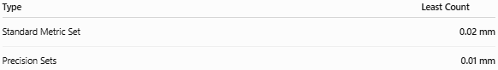
Type | Least Count
Standard Metric Set | 0.02 mm
Precision Sets | 0.01 mm

How to Measure with a Feeler Gauge
# Source: AI Source: Provided by: [Data Path: Persons Table -> ID Column: 1, Name_En Column: Motasem Essam] -> From: [ChatGPT] on [7/17/2026]
- Clean the surfaces.
- Select a blade close to the expected gap.
- Insert the blade into the gap.
- Check the fit:
  - Too loose → use a thicker blade.
  - Too tight → use a thinner blade.
- If necessary, combine multiple blades.
- Record the total blade thickness.

Example
# Source: AI Source: Provided by: [Data Path: Persons Table -> ID Column: 1, Name_En Column: Motasem Essam] -> From: [ChatGPT] on [7/17/2026]
Suppose:
- Blade A = 0.30 mm
- Blade B = 0.05 mm
Combined thickness:
0.30+0.05=0.35 mm0.30 + 0.05 = 0.35\ \text{mm}0.30+0.05=0.35 mm
The measured clearance is:
0.35 mm

Accuracy
# Source: AI Source: Provided by: [Data Path: Persons Table -> ID Column: 1, Name_En Column: Motasem Essam] -> From: [ChatGPT] on [7/17/2026]
Typical accuracy:
- ±0.005 mm
- ±0.01 mm
Accuracy depends on:
- Blade wear
- Surface cleanliness
- Manufacturing quality
- Proper insertion technique

Sources of Error
# Source: AI Source: Provided by: [Data Path: Persons Table -> ID Column: 1, Name_En Column: Motasem Essam] -> From: [ChatGPT] on [7/17/2026]
Instrument Errors
- Worn blades
- Bent blades
- Corrosion
- Incorrect thickness marking

Observation Errors
- Choosing the wrong blade
- Incorrect interpretation of blade fit

Positioning Errors
- Blade inserted at an angle
- Dirt between surfaces
- Excessive insertion force

Environmental Errors
- Temperature changes
- Oil or grease between surfaces
- Rust or debris

Applications
Feeler gauges are used in:
- Automotive maintenance
- Valve clearance adjustment
- Spark plug gap measurement
- Machine setup
- Manufacturing
- Precision engineering
- Quality control
- Equipment maintenance

Advantages
# Source: AI Source: Provided by: [Data Path: Persons Table -> ID Column: 1, Name_En Column: Motasem Essam] -> From: [ChatGPT] on [7/17/2026]
A Feeler Gauge:
- Is simple to use.
- Provides high precision.
- Is inexpensive.
- Measures very small gaps.
- Requires no power.
- Is portable and durable.

Limitations
# Source: AI Source: Provided by: [Data Path: Persons Table -> ID Column: 1, Name_En Column: Motasem Essam] -> From: [ChatGPT] on [7/17/2026]
A Feeler Gauge:
- Measures only gaps or clearances.
- Cannot measure long linear dimensions.
- Requires physical access to the gap.
- Blade wear may reduce accuracy over time.

Comparison with Other Length Measuring Instruments
# Source: AI Source: Provided by: [Data Path: Persons Table -> ID Column: 1, Name_En Column: Motasem Essam] -> From: [ChatGPT] on [7/17/2026]
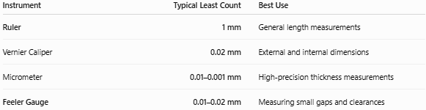
Instrument | Typical Least Count | Best Use
Ruler | 1 mm | General length measurements
Vernier Caliper | 0.02 mm | External and internal dimensions
Micrometer | 0.01–0.001 mm | High-precision thickness measurements
Feeler Gauge | 0.01–0.02 mm | Measuring small gaps and clearances

Care and Maintenance
# Source: AI Source: Provided by: [Data Path: Persons Table -> ID Column: 1, Name_En Column: Motasem Essam] -> From: [ChatGPT] on [7/17/2026]
To maintain accuracy:
- Keep blades clean and dry.
- Apply light oil to prevent rust.
- Avoid bending the blades.
- Store the blades folded when not in use.
- Replace worn or damaged blades.

Common Mistakes
# Source: AI Source: Provided by: [Data Path: Persons Table -> ID Column: 1, Name_En Column: Motasem Essam] -> From: [ChatGPT] on [7/17/2026]
- Forcing a blade into the gap.
- Measuring dirty surfaces.
- Using bent or worn blades.
- Forgetting to add the thicknesses of stacked blades.
- Selecting the blade based on force instead of a light, consistent drag.

Key Points
# Source: AI Source: Provided by: [Data Path: Persons Table -> ID Column: 1, Name_En Column: Motasem Essam] -> From: [ChatGPT] on [7/17/2026]
- A Feeler Gauge measures small gaps and clearances.
- It consists of thin blades of known thickness.
- Typical least count:
  - 0.02 mm
  - 0.01 mm (precision sets)
- Multiple blades can be combined to obtain intermediate thicknesses.
- It is widely used in automotive, mechanical engineering, machining, and quality control.

Conclusion
# Source: AI Source: Provided by: [Data Path: Persons Table -> ID Column: 1, Name_En Column: Motasem Essam] -> From: [ChatGPT] on [7/17/2026]
A Feeler Gauge is a precision measuring instrument specifically designed to determine the width of narrow gaps and clearances between mechanical components. Using accurately manufactured blades of known thickness, it enables technicians and engineers to inspect and adjust critical clearances such as engine valve gaps, spark plug gaps, bearing clearances, and machine alignments. Its simplicity, portability, and high precision make it an essential tool in mechanical engineering, manufacturing, automotive maintenance, and industrial quality control.

